Table 3: Sample Rows for the Big Order Database Table

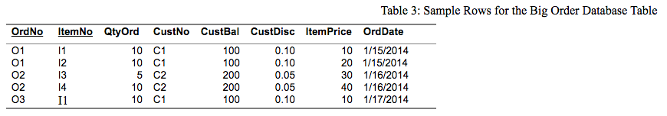

**Answer:**

OrdNo→ItemNo **(1,2), (3,4)**

OrdNo→QtyOrd**(3,4)**

OrdNo→CustNo **NONE**

OrdNo→CustBal **NONE**

OrdNo→CustDisc **NONE**

OrdNo→ItemPrice **(1,2),(3,4)**

OrdNo→OrdDate **NONE**